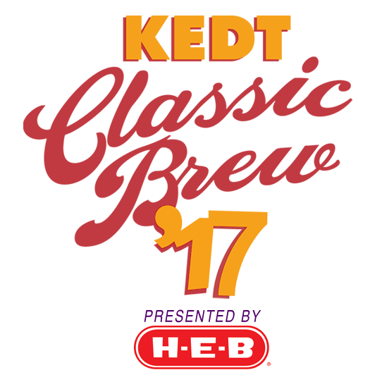
2017 Sponsorship Sign-Up Form

Contact Information
Company/Organization: ________________________________________________________
Contact Name: _______________________________________________________________
Address: _________________________________ City: ______________________________
State: _______________________________ Zip: ___________________________________
Phone: (______) _________ - ______________
E-Mail: _____________________________________________________________________

Payment Method
My Check Is Enclosed_______________ Please Invoice Me________________
Charge My: AMEX_______ MC_________ Visa_________ Disc____________
Account #______________________________ Expiration Date___________ V-Code_______

Signature ________________________________________________________________

Please Check Sponsorship Level
_____ $2,500 Premium Lager Sponsorship
_____ $2,000 Brew Master Sponsorship
_____ $1,500 Stout Supporter Sponsorship
SOLD! T-Shirt Sponsor - $2,500 ( B&J’s Pizza Restaurant)

E-mail To: stevehindman@kedt.org
or Mail To: KEDT Attention: Steve Hindman
3205 S. Staples
Corpus Christi TX 78411

KEDT Is A 501 C(3) Nonprofit Organization

